# Abstract

**Purpose –** The purpose of this study is to investigate the impact of social media marketing (SMM) on consumer purchase intention by analyzing how various social media strategies influence consumer purchase decisions in digital environments. This study addresses the following research question, “How does social media marketing impact consumer purchase intention?” By synthesizing the findings from existing literature, the study aims to enhance theoretical understanding as well as provide practical insights in this domain.

**Methodology –** The study utilizes the Systematic Literature Review (SLR) method, which encompasses structured search and selection process to find relevant articles. Initially, 60 relevant articles were found through primary databases after a comprehensive search process. By applying inclusion and exclusion criteria 20 highly relevant articles were selected. To identify key themes and provide an extensive understanding of social media’s role in shaping consumer purchase intention thematic analysis was conducted.

**Findings –** The study indicates that consumers’ purchase intention is significantly influenced by various SMM factors. By utilizing multi -platform strategies, customized engagement and precise product information, Influencer marketing enhances brand trust. Customer engagement in SMM enhances brand image and loyalty, particularly through content and affiliate marketing. Emotional and physiological factors such as flow experience, utilitarian and hedonic value also influence consumer purchase intention.

**Research limitations-** Time constraint, reliance of secondary data and restrained access to paid research articles are the main limitations. The time constraint caused exclusion of important findings from existing research. The reliance of secondary data has impacted the depth and thoroughness of the review. Due to limited access to available research, focusing on articles published between 2019-2024 the study faced sample bias.

**Implications-** This study validates existing insights while advancing theoretical understanding of how SMM impact consumer purchase intention through various factors. While highlighting the importance of leveraging these factors in designing effective marketing strategies, this study offers practical implications for marketers. These insights facilitate marketers in refining their strategies and attract more customers and drive purchase decisions.

**Key words –** Social media marketing, purchase intention, digital marketing, consumer engagement,

# Acknowledgements

I am deeply grateful to my supervisor Dr. Nitin Seth, for providing me with invaluable guidance and constructive feedback throughout each stage of this research. His expertise and continuous observations have greatly influenced in enhancing the accuracy and relevancy of the study. I am also greatly thankful to the members of the research committee who approved my research topic and provided me with this valuable learning opportunity.

Additionally, I am sincerely grateful to my academic colleagues for their support in sharing their opinions and resources, which have deepened my understanding of the subject and inspired me to put an extra effort to improve the quality of my study. Ultimately, I am truly grateful to my family and friends for their continuous encouragement and support during this journey. Their patience and understanding, especially from my husband and two sons, were instrumental in the successful completion of this research.

**Table of Contents**

Contents

Abstract iii

Acknowledgements iv

Chapter 1: Introduction 8

1.1. Chapter overview 8

1.2. Background 8

1.3. Research motivation (gaps) 9

1.4. Research objective/aim 10

1.5 Research question 10

1.6 Research significance (theoretical and practical) 10

1.7 Chapter summary 11

Chapter 2: Method 12

2.1 Chapter overview 12

2.2 Systematic Literature Review 12

2.3 Key terms 12

2.4 Search strategy 13

2.4 Eligibility criteria (inclusion and exclusion) 13

2.4.1. Inclusion criteria 13

2.4.2 Exclusion criteria 13

2.5.2. Selection of highly relevant articles 15

2.6 Ethics and ethical consideration 15

Chapter 3: Literature review 16

3.1. Chapter overview 16

3.2. Synthesis of Landmark study 16

3.2.1. Landmark studies 16

3.2.2. Landmark study 1- 17

3.2.3. Landmark study 2- . 17

3.2.4. Landmark study 3-. 18

3.3 Definition table/Concepts and terms 19

3.4 Theories and theoretical models in previous research 20

3.5. Findings from previous literature and recurring themes. 21

3.5.1 Introduction 21

3.5.2 Theme 1- Impact of social media influencers in creating brand trust leading to purchase intention 21

3.5.3. Theme 2: Impact of social media consumer engagement in building brand image, leading to purchase intention 24

3.5.4. Theme 3: Impact of emotional and pshycological factors influencing purchase intention through social media marketing 26

3.6 Summary of findings from previous literature 27

3.7 Methodological approaches used in previous studies 28

3.7.1. Table 4- Research methods 28

3.7.2. Table 5 -Sampling methods 28

3.7.3. Table 6- Data Collection approaches 30

3.7.4. Table 7- Data analysis approaches 31

3.8 Research gaps in previous literature 32

Chapter 4: Discussion 33

4.1. Chapter overview 33

4.2. Contribution of this research 33

4.2.1 Theoretical contribution 33

4.2.2 Practical contribution 34

4.3 Conclusion 35

4.4. Limitations 35

4.5 Future Research 36

5.Reference list 37

6.Appendices 40

6.1. Application for research 40

6.2. Approval letter 43

6.3. supervisor submission agreement 44

6.4. Annotated Bibliography 45

**List of tables**

Table 1- key terms …………………………………………………………………………………………………………………………..12

Table 2 - Definition table/Concepts and terms…………………………………………………………………………………19

Table 3- Theories and theoretical models in previous research………………………………………………………. 20

Table 4- Research methods……………………………………………………………………………………………………………. 28

Table 5- Sampling methods …………………………………………………………………………………………………………….28

Table 6- Data collection approaches……………………………………………………………………………………………….30

Table 7- Data analysis approaches………………………………………………………………………………………………….31

**List of figures**

Figure 1- PRISMA flow diagram……………………………………………………………………………………………………14

**Abbreviations**

SLR – Systematic Literature Review

SMM- Social Media Marketing

PRISMA- Preferred Reporting Items for Systematic Reviews and Meta-Analysis

ABDC- Australian Business Deans Council

TAM- Technology Acceptance Model

TPB- Theory of Planned Behavior

TIB – Theory of Interpersonal Behavior

UGT- User Gratification Theory

CBE- Consumer Brand engagement Theory

UGC- User- Granted Content

FGC- Firm-Granted Content

# Chapter 1: Introduction

## 1.1. Chapter overview

This chapter begins by presenting background information on the research area, particularly, SMM impacts on consumer purchase intention. Then the discussion of the motivation for conducting the research presents while highlighting the gaps in existing literature. It outlines the research objectives/aim along with the research questions. Ultimately, this chapter concludes by discussing the importance of the research in both theoretical and practical contexts.

## 1.2. Background

In recent years, the development of digital platforms has altered the ways companies interact with their customers. With the advent of digital marketing, consumers adopt social media to seek product information and recommendations which has significantly impacted on consumer purchasing behavior. (Eveans et al.,2017). According to the study by McKinsey & company, 75% of consumers are adopt to online platforms for shopping, entertainment and communication during the pandemic period and these behaviors are accelerated by need for convenience and advanced digital adoption.(Charm et al., 2020). The role of social media in driving consumer behavior and purchase intention is unquestionable as social media platforms like Facebook, Instagram, Twitter and TikTok act as a tool to engage with customers directly, build trust and promote brand loyalty. (Sarin et al., 2023). In 2024, there are over 5 billion social media users worldwide and this figure is expected to increase to over 6 billion by 2028, with the increased accessibility and popularity of these platforms. (Statista, 2024).

With the rise of digital technologies and various social media platforms consumers are seeking more specific and engaging content when they make decisions on what to buy. They highly depend on ratings and reviews from peers. Further, Deloitte reports on consumer behavior explains that advancement in digital technologies like AI and data analytics have significantly impact on digital marketing tools and social media platforms, thereby influencing customer preferences and brand loyalty. (Deloitte, 2021).

Growth of influencer marketing supports this trend with the market value at $21.1 billion in 2023, is expanding at a rate of more than 17% annually. Influences play an effective role in building brand trust and encouraging purchase intention, particularly within specific demographic segments, highlighting the role of social media in promoting consumer engagement and purchase intention. (Influencer Marketing Hub, 2024).

With the ability to influence and engage customers, an important question arises: how these platforms exactly impact consumer purchase intention? According to Neilson’s 2020 Global Trust in Advertising report, 79% of consumers report their purchasing decisions are impacted by user granted content on social media. This study further reveals that 69% of participants trust advertisements on reputable websites which reflects a 9% increase from 2013. Additionally, when making purchasing decisions, 69% of global consumers trust online reviews as their critical source of information. (Neilson, 2020). This growing trust in social media advertising highlights the significant role of SMM in shaping consumer purchase intentions.

Considering the crucial role social media plays in shaping consumer behavior and purchase intention, it is important to understand and investigate how different SMM techniques impact on consumer purchase intention. The understanding of these elements is essential for developing marketing strategies which are founded in both academic research and practical perspectives.

## 1.3. Research motivation (gaps)

The topic, the impact of SMM on consumer purchase intention is often complex and continuously changing. Most of the previous studies focused on specific, distinct characteristics which resulted in a limited understanding of interrelated factors influencing purchase intention. This SLR aims to fill this gap by providing a comprehensive view and investigate how SMM strategies impact consumer purchase intention through brand trust, brand image, psychological and emotional engagement.

Prior research has examined specific aspects, such as how influencers enhance brand trust and effective influencer interaction can boost customer engagement. (Duffett & Maraule, 2024). However, these studies often disregard how elements like multi-platform interaction and customization in social media content contribute to establishment of trust. Although some research indicates that affiliate marketing and content marketing strategies might influence brand loyalty and awareness, still less has been discovered on how these engagements tools impact brand image broadly. (Zeqiri et al., 2024).

Further, it has been identified that utilitarian and hedonic value which serves as phycological, and emotional drivers are also crucial factors in influencing purchase intention. (Zhang et al., 2023). However, in the context of social media some factors such as flow experience and privacy concern affect purchase intention remain unexplored.

Thus, by synthesizing all these aspects this SLR provides fresh perspective on how businesses can leverage social media strategies to boost consumer engagement, establish trust and drive purchase intention. Combining both theoretical and practical applications, this approach expands the knowledge in the field of SMM and offers practical recommendations for marketers, aiming to maintain competitive advantage in an evolving digital marketplace.

## 1.4. Research objective/aim

Research objective is to systematically review the existing literature on the impact of SMM on consumer purchase intention while focusing on the key factors that drive buying decisions of the consumers. Particularly, it aims to examine how different elements such as brand engagement, brand loyalty, brand consciousness, consumer attitudes, consumer trust, and influencer marketing affect consumer intention towards purchasing decisions. By addressing these elements, this research will offer valuable information regarding what digital marketing strategies drive consumer purchase intention and provide recommendations for businesses to strengthen their marketing initiatives.

Additionally, by considering the generation gap and digital marketing dynamics, this research will examine how SMM strategies can be enhanced to effectively engage with generation Z consumers given their increasing influence as a generation raised with digital technologies.

## 1.5 Research question

The research question, “How does social media marketing impact consumer purchase intention?” seek to understand the various ways in which SMM strategies impact consumer’s intention to make purchase. It focuses on both direct and indirect effects of how brand engagement, brand trust, loyalty and influencer marketing together shape consumer purchase decisions. Additionally, by focusing on unique behaviours and perceptions of Gen Z consumers, the research question aims to address which aspects of SMM are most effective in converting young consumer interest into actual purchase intentions.

## 1.6 Research significance (theoretical and practical)

This research is important in both theoretical and practical perspectives. By contributing fresh perspective into how specific aspects such as emojis, brand loyalty, brand trust and influencer marketing, this SLR enhance the current frameworks theoretically. Synthesis of such frameworks as, Technology Acceptance Model (TAM), Theory of Interpersonal Behaviour (TIB), Theory of Planned Behaviour (TPB), Zeisser Model and User and Gratification Theory (UGT) collectively provides improved understanding of the factors in SMM which impact consumer purchase intention. This research identifies the gaps and inconsistencies in the current literature which will provide a strong foundation for development of new theoretical models which open opportunities for future studies in this field.

Additionally, in practical terms, this research shed lights on valuable information for marketers and business. In particular, the research shed light on key marketing trends, such as growth of influencer marketing and digital technologies in shaping consumer purchase intention. These insights are crucial for businesses to execute more effective marketing campaigns, increase customer engagement and eventually increase sales. With the continuous growth of social media use, this research will specifically be significant for businesses who seek to enhance digital marketing strategies while maintaining competitive advantage in today’s rapidly changing digital environment.

## 1.7 Chapter summary

This chapter discovers the background information related to the research topic, “The impact on social media marketing on consumer purchase intention” by covering the development and significance of SMM, supported by latest statistics. The motivation (gap) presented for the study, based on the gaps identified in the pervious literature. This chapter outlines the research objective and question by concluding the theoretical and practical contributions of the research. The following chapter will cover the methodology used in this SLR including data collection, data analysis and sampling methods which are synthesized to achieve the research objective.

# Chapter 2: Method

## 2.1 Chapter overview

This chapter presents the research methodology which is used to analyse and evaluate the existing literature pertinent to research topic. First section consists, discussion of integrative review method which allows an analysis of various findings. Then the key terms and search strategy used to find relevant articles is discussed with an explanation of eligibility criteria including inclusion and exclusion of studies. Finally, screening and selection process to discuss the transparency and accuracy in article selection along with ethics and ethical considerations are presented.

## 2.2 Systematic Literature Review

The SLR method offers accurate and fair overview by employing a systematic search strategy to find, analyse and interpret relevant literature on a specific topic. SLR ensures the comprehensive and consistent findings which highlight existing knowledge, identify gaps and propose future research. (Kitchenham & Charters, 2007). Given that, this study employs SLR method to facilitate a thorough understanding of consumer engagement and purchase intention through SMM, making it well suited for synthesis different perspectives.

The PRISMA (Preferred Reporting Items for Systematic Reviews and Meta-Analyse) framework has used to enhance the methodological rigor and streamline the article selection process. It demonstrates a systematic approach followed to filter relevant articles on the research topic by outlining the number of articles identified, screened, evaluated for eligibility and included or excluded in the review. (University of Derby Library, 2023).

## 2.3 Key terms

To identify relevant articles and ensure clarity, the following key terms have been used.

Table 1

|  |  |
| --- | --- |
| Key term | Relevance to the study |
| Social media marketing | Focuses on the impact of SMM strategies on consumer engagement and intention to purchase |
| Digital marketing | Explore all marketing efforts done through electronic devices influence consumer behaviour and influence online purchase intention |
| Purchase intention | This term is central to the study objective, as it examines how SMM and digital marketing strategies impact on consumer’s intention purchase products/services. |
| Consumer behaviour | Explore how SMM and digital marketing strategies influenced by consumer behaviour patterns. |
| Consumer engagement | Analyse the way consumers engage with the brand and how it will lead to brand trust, awareness and engagement. |

These key terms have been combined by using Boolean operators, AND/OR which provide a thorough

examination of how SMM impact on consumer purchase intention.

## 2.4 Search strategy

To find the relevant existing literature on the topic, “impact of social media marketing on customer purchase intention”, a systematic search strategy was developed in two stages. The first stage involves database selection which include large collection of peer reviewed journals and articles about SMM and consumer purchase intention. Such selected databases as ProQuest, Science Direct, Scopus, and they were selected for two reasons. Firstly, they offer extensive range of articles from credible sources and guarantee the reliability of the research.

In the second stage, the search was conducted in two phases. In phase one, key terms such as “social media marketing” AND “purchase intention” were used to identify general articles on the topic. Phase two of the search conducted by using Boolean operators along with the key terms. These Boolean operators were used to further refine the search process and to ensure that articles are most relevant to the study. Such key terms are “consumer engagement” OR “influencer marketing” OR “consumer engagement” AND “consumer purchase intention” OR “digital marketing.” filtering the search by focusing on elements in SMM and its impact on consumer purchase intention.

## 2.4 Eligibility criteria (inclusion and exclusion)

### 2.4.1. Inclusion criteria

Multiple inclusion criteria were employed to ensure chosen literature was pertinent and align with the research topic. First, only peer reviewed journal articles published within the last 5 years (2019-2024) were selected to ensure the high standard of research quality and findings are in line with the current trends and developments in SMM. Secondly, prioritized the articles which are specifically discussed the relationship between SMM and purchase intention. Finally, empirical studies with both qualitative and quantitative data on the topic were selected to provide an extensive analysis of the topic.

### 2.4.2 Exclusion criteria

Exclusion criteria were used to filter out the articles which are not relevant to the study. First, articles published before 2019 were omitted to gather recent findings and maintain the focus on recent trends as well as development in SMM. Since this review depend on peer reviewed journal articles with empirical data, the articles from book chapters, systematic literature reviews and conference papers were excluded as they are often non-peer reviewed and not provide empirical data. The articles without full text access also excluded. Further, the articles those findings are not related to the relationship between SMM, and purchase intention were excluded as well.

Ultimately, 110 articles were selected by carefully filtering the research papers based on above mentioned inclusion and exclusion criteria and utilized in a detailed review.

2.5 Screening and Selection

To guarantee the transparency and rigor of the literature selection process, PRISMA (Preferred Reporting Items for Systematic Reviews and Meta-Analysis) framework were utilized for screening and selection of relevant articles in this systematic literature review. The PRISMA flow diagram (figure 1) specifically designed for this review as follows:

Note. Compiled by author by using the PRISMA 2020 flow diagram template.

2.5.1. Selection criteria

After applying inclusion and exclusion criteria, selected articles were prioritized which are published in journals ranked A*, A and B by the Australian Business Deans Council. (ABDC). The primary focus of the selected articles is on the relationship between SMM and consumer purchase intention, including SMM strategies, brand equity factors and consumer engagement.

Specifically, the articles which address the youth consumer engagement with SMM, and it impact on purchase intention were considered to examine how attitudes and behaviours of the current generation impact purchase intention via SMM.

To exclude the articles which did not directly address the research topic or relevant findings, an additional filtering process were conducted during the final screening process. Even though some articles were initially selected due to key word misrepresentation, for example, some studies were generally discussed the relationship between SMM and consumer behaviour but did not specifically address the relationship between SMM and purchase intention. Since these articles findings did not align with the primary research focus, they were carefully reviewed and excluded during the final screening process. Following this careful evaluation 60 articles were selected for further consideration.

### 2.5.2. Selection of highly relevant articles

Out of these 60 articles, 20 highly relevant articles were selected for further examination. Most of these articles were taken from A* or A ranked journal including ScienceDirect, Scopus in ABDC which are recognized due to their high impact factor or cite score. Such articles were selected based on their contribution to understanding of the research topic, methodological rigor and the level of analysis. During this selection process, some recently published articles which presents innovative findings were found. But had lower citation score. In those cases, to ensure the thorough representation of the research, additional factors were considered such as, content quality of the article, author’s background and the journal quality.

## 2.6 Ethics and ethical consideration

Since this literature review used secondary data from easily accessible research article, personal data was not included in the data collection process. Nevertheless, when examining these research articles, confidentiality of the original data and respect for the intellectual property rights were strictly adhered. Specifically, all referenced work including concepts, theories and findings has been professionally acknowledged according to APA 7 reference style by respecting the intellectual property rights of original authors and researchers. To minimize the research bias, critically evaluate the different articles with conflicting findings and consider the multiple views. Additionally, when selecting and analysing articles, all attempts was made to remain objective, especially interpreting findings related to the impact on social media marketing on consumer purchase intention.

On the other hand, to maintain the academic integrity, this study prioritizes the article which are from high ranked journals and reputable databases by ensuring data analysis was credible and scientifically accurate. Further, to provide a fair and accurate view of the topic, articles were chosen based on the quality and relevancy rather than convenience.

# Chapter 3: Literature review

## 3.1. Chapter overview

This chapter presents a broad analysis of existing literature on how social media marketing impact on consumer purchase intention. An analysis of landmark studies is included emphasizing their importance and contribution to the field followed by the definitions of key terms and concepts. Then the main theoretical framework/models used in the previous literature are discussed. The findings of the previous literature are categorized into specific themes, identifying recurring connection between SMM strategies and purchase intention. Finally, summary of key findings of previous literature and methodological approaches such as sample methods, data collection/analysis approaches and research gaps in previous literature presented.

## 3.2. Synthesis of Landmark study

### 3.2.1. Landmark studies

The first landmark study “Do social media marketing activities enhance customer equity? An empirical study of luxury fashion brand” by Kim & Ko, (2012) is credible research conducted on the impact of SMM activities on consumer equity. This article was published in a Journal of Business Research, a reputable peer reviewed journal. Its substantial citation count, (cited by 4306) with the journal’s higher impact factor of 10.5 indicates its extensive influence and acceptance. (Elsevier, ScienceDirect, 2024). Thus, higher journal quality factors along with its rigorous methodological approach, and relevance to modern marketing practices, establish it as a landmark study in the field of SMM.

The second landmark study “Influence of social media marketing communications on young consumers” Duffett, R.G. (2017) is credible research. It addresses the influence of interactive SMM communications on young consumer’s purchase decisions and behavior. This article has been cited by 708 studies and has an impact factor of 4.1 (Resurchify 2024) indicates its higher journal quality. This study has been cited in four of the 20 reviewed articles, indicating its ongoing contribution to current studies in the field of SMM. By providing valuable insight into how various elements of SMM influence consumer attitudes and behaviors, position this study as a landmark study in the field of online consumer behavior.

The third landmark study “The theory of planned behavior. Organizational Behavior and Human Decision Process” by Ajzen, I. (1991), which has introduced Theory of Planned Behavior (TPB). This article has been cited by 56857 studies, indicating that TPB has become widely referenced and an influential theory in understanding human- decision making and behavior. By offering an initial framework for examining how attitudes, subjective norms, perceived behavioral control impact on purchase intention, this study has made a significant contribution to the field of SMM and consumer behavior.

### 3.2.2. Landmark study 1-Do social media marketing activities enhance customer equity? An empirical study of luxury fashion brand. - Kim & Ko (2012).

Kim & Ko (2012) has conducted a fundamental investigation while introducing empirically validated five constructs in perceived SMM activities such as customization, trendiness, entertainment, interaction, word of mouth and their relationship between customer equity such as value equity, customer equity and brand equity. This study has discovered how these constructs positively impact value equity, relationship equity and eventually purchase intention by utilizing structural equation modeling approach.

The significance of this study derives from its precise methodology and its capability to provide fresh insight on how effective SMM activities can promote greater customer relationships and increase brand equity.

When analyzing 20 articles, it was found that several articles have discussed these five constructs in their study and have used them as a basis for hypothesis building. For instance, these studies established hypothesis to test the impact of these constructs on purchase intention and customer engagement. According to study by Zeqiri et al., (2024), one hypothesis suggests, perceived social media marketing (social interaction, trendiness/informational, entertainment) positively influences on social media brand engagement. By highlighting the role of engaging and entertaining content on consumer behavior, the findings support the Kim & Ko (2012) assertion which entertainment is a crucial aspect of SMM activities.

Other articles findings such as Zulqarnain et al., (2023), Pinca et al., (2024) and Chuah et al., (2023) further, emphasize that engaging and entertaining SMM campaigns not only create brand awareness and develop user engagement with brands, but also influence purchase intention positively. Specifically, Zulqarnain’s findings highlight interactive content plays a significant role in building strong consumer-brand relationships. Additionally, Pinca’s findings emphasized SMM activities namely influencer endorsement and visible information increase the brand recognition and lead to higher purchase intention. Further, Chuah’s study aligns with Kim & Ko’s (2012) findings on entertainment and trendiness, by showing these factors are significant in influencing purchase intention.

### 3.2.3. Landmark study 2- Influence of social media marketing communications on young consumers’ attitudes. Duffett, R.G. (2017).

This study examines how SMM significantly impacts young consumers attitudes through three key areas, such as cognitive, affective and behavioral. Especially, the findings emphasize that even though SMM greatly impacts on initial brand awareness and create positive experience, its impact on actual purchase decision might diminish over time. which aligns with the purchase funnel model which explains, even though consumer engagement is high in the initial stages, ultimately, fewer consumers proceed to the purchase stage. However, the findings also highlight the importance of visual and engaging content on SMM platforms and suggest that when brands utilize creative and engaging content, young consumers respond positively.

This positions SMM as a powerful tool not only for developing brand awareness but also for building loyalty which fosters lasting relationships with young consumers. Thus, by interacting both theoretical framework with practical applications this study provides greater insight into consumer behavior in the digital landscape.

When synthesizing this finding with the four articles that have cited this study, Arindaputri & Santoso (2023) also found that both brand loyalty and purchase intention has directly impacted by digital marketing strategies including brand image and perceived price. Extending this idea, the study by Kaluarachchi & Jayasuriya has examined the role of consumer brand engagement and purchase intention while highlighting that both user-generated and firm- created social media content significantly impact purchase intention. Further, the study by Duffett & Maraule (2024), “the role of emojis in digital marketing affect Gen Z’s purchase intention” and the study of “online motivations on purchase intention” by Zhang et al., (2023) has supported Duffett’s (2017) findings by highlighting creative, attractive and relatable SMM content boost consumer engagement and promote positive brand attitudes.

### 3.2.4. Landmark study 3 –The theory of planned behavior. Organizational Behavior and Human Decision Process. Ajzen, I. (1991).

The article by Ajzen, I. (1991) introduced the Theory of Planned Behavior (TPB) which is groundbreaking work in the field of social psychology and behavioral studies. This theory particularly has expanded the previous Theory of Reasoned Action (TRA) by examining perceived behavioral control as a key variable of individual’s intention and behavior. Since this study provides a structural framework for understanding how perceived behavioral control, attitudes and subjective norms influence intention and behavior, it’s especially relevant to studies which examine consumer purchase intention in social media context. As demonstrated by Ajzen’s study, these constructs are strong predictors of actual behavior which predicts behavioral intentions consistently. Thus, by introducing a strong framework like TPB, this study has contributed significantly to the field, especially purchase intention in marketing context.

The article by Tirtayani et al., (2024) has applied TPB in their study and has found that purchase intention is directly influenced by attitudes towards brand trust and perceived control over decisions. This finding aligns with Ajzen’s study, if people trust the brand and believe they are able to make the decision, they are more likely to finalize the purchase. Similarly, Qin et al., (2024), Zulqarnain et al., (2023) has found that both attitudes and subjective norms such as influencer opinions are crucial in influencing purchase intention. By supporting Ajzen’s framework, this study highlights that when consumers feel they have ability to engage with content easily they are more likely to make purchases.

## 3.3 Definition table/Concepts and terms

Table 2

|  |  |  |
| --- | --- | --- |
| Key concepts/terms | Definition | References |
| Digital marketing | Electronic social media marketing which uses web technologies to interact with public communities. | Arindaputhri & Santoso, 2023), (Almohaimmeed 2019), (Trianasari et al., 2023) |
| Brand image | Brand image associated with a specific offering and consisted of a functional and symbolic attribute. It provides an important factor for consumers to differentiate a brand from its competitors. | (Arindaputhri & Santoso, 2023), (Salhaba et al., 2023), (Trianasari et al., 2023) |
| Price perception | It’s a general perception of the average price which customers connect with a specific retailer. | (Arindaputhri & Santoso, 2023) |
| Purchase intention | Purchase intention is the attitude of consumer’s interest and potential of making a purchase from a particular brand or product. It can be used as a measurement to predict future behaviors. | Arindaputhri & Santoso, 2023), (Radwan et al, 2021), (Sarin & Sharma, 2023), (Trianasari et al., 2023) |
| Brand loyalty | Brand loyalty is the desire of consumers to make multiple purchases from the same brand with the belief of brand value is higher than other choices. | El-Sherbiny & Al-Romeedy, 2023), Arindaputhri & Santoso, 2023), |
| Social media | It’s a collection of online applications which combine ideological and technological applications such as Web 2.0. These applications facilitate communication, creation, and content sharing among consumers. | (Irshad & Ahamad, 2019), (Kaluarachchi & Jayasuriya, 2024). |
| Utilitarian motivation | Utilitarian value is often related to consumer’s cognitive or informational needs. It provides significant practical and customer focused thinking which assists making purchase decisions. | (Irshad & Ahamad, 2019) |
| Hedonic motivation | Hedonic motivation explains the entertainment/ enjoyment developed from an activity. The hedonic aspect of motivation can be identified as feelings, fun and fantasies. | (Irshad & Ahamad, 2019) |
| Brand Trust | Confidence that customers have in a specific brand’s capacity to deliver its promises. | (Hanaysha, 2022), (Sarin & Sharma,2023), (Trianasari et al., 2023) |
| Influencer marketing | It’s a method of promoting goods and services by collaborating with individuals who have significant influence on their target market. | (Radwan et al., 2021), (Trianasari et al., 2023) |
| Social media marketing | SMM encompasses creating and sharing content on social media platforms such as Facebook, Twitter, Instagram and LinkedIn, to interact with the target audience, increase brand awareness, and increase sales. | (Trianasari et al., 2023) |

## 3.4 Theories and theoretical models in previous research

Table 3

|  |  |  |
| --- | --- | --- |
| **Theories and theoretical models** | **Descriptions** | **References** |
| Technology Acceptance Model (TAM) | TAM explains the acceptance and steady intention to use new technologies, products/ services in their early stages. | (Duffett & Maraule, 2024) |
| Theory of Planned Behavior (TPB) | A person’s attitude, behavioral control and subject norms affect his behavior. | (Tirtayani et al., 2024), (Qin et al., 2024) |
| Theory of Interpersonal Behavior (TIB) | Created to predict the interactions among the people. According to TIB, a person’s behavior is influenced by three things, such as intention, habit and facilitating conditions. | (Tirtayani et al., 2024) |
| The Zeisser Model | Provides comprehensive understanding of digital marketing by breaking down it to five dimensions. Such as, attract, engage, retain, learn and relate. | (El-Sherbiny & Al-Romeedy, 2023) |
| Pleasure-Arousal-Dominance model (PAD) | A PAD model is a framework which explains and describes human emotions in three measurements. Such as pleasure, dominance and arousal. | (Zhang et al., 2023) |
| Flow theory | Flow experience is a mental state in which an individual is completely involved and highly concentrated on a task. | (Zhang et al., 2023) |
| User and Gratification Theory | It is a framework to explain how and why customers are continuously seeking particular media to fulfil their needs. This theory consists of three types of consumer motivation including utilitarian, hedonic, and content personalization. | (Irshad & Ahamad, 2019), (Zeqiri et al.,2024) |
| Consumer brand engagement theory (CBE) | CBE describes, to what extent customer’s interaction, emotional connection, and use a brand within social media context. It includes three dimensions. Such as, cognitive, behavioral, affective. | (Zeqiri et al.,2024) |

## 3.5. Findings from previous literature and recurring themes.

### 3.5.1 Introduction

In the digital environment, particularly in the context of SMM consumer purchase intention has shaped due to various factors. A review of 20 articles highlights three main recurring themes in SMM which influence consumer purchase intention. Each theme, including role of influencer marketing, consumer engagement, emotional and phycological factors contributes to different stages of consumer journey starting from brand awareness to trust and eventually purchase intention. The role of influencers in social media is crucial in creating brand trust, which is an essential component to build long term relationships with customers and brands. Customer engagement also plays a crucial role in enhancing brand image and strengthening brand trust while influencing customer’s view and connections with brands. Additionally, psychological and emotional factors significantly impact consumers privacy and purchase habits by addressing their motivations and concerns. These themes demonstrate an intricate procedure of trust building among consumers which contribute to strong purchase intention through SMM.

### 3.5.2 Theme 1- Impact of social media influencers in creating brand trust leading to purchase intention

The findings of multiple articles offer significant understanding in to how social media influencers, their activities create brand trust and ultimately influence consumer purchase intention. Sarin & Sharma 2023 has stated that higher impact of SMM activities on consumers leads to increased brand trust and purchase intention. Sarin & Sharma (2023) further explained that trust towards a particular brand help to create desire and need of the consumers mind and will result in repeating purchasing behaviour. Moreover, Influencer marketing is a method of promoting goods and services by collaborating with individuals who have significant influence on their target market. (Radwan et al., 2021, Trianasari et al., 2023). Influencers can persuade followers through interactivity, confidence, authenticity and trust while creating strong connection between brand and consumers. (Radwan et al., 2021).

#### 3.5.2.1 Sub theme 1: Effectiveness of influencer marketing in building brand trust

Social media influencer marketing has emerged as a powerful tool for developing brand trust which in turn impact consumer purchase intention. The findings of the study by Radwan (2020) have emphasised that influencers not only promote product/services but also, they act as a trustworthy mediator, creating engaging content to encourage consumers. Especially, youth who search for information, interact with brands and ultimately make purchase decisions. Influencers create personal and interactive experiences which resonate with their followers by utilizing various digital content format such as videos, live chat, posts and stories. The study has explained the posts and videos act as testimonials and lead to word-of-mouth marketing which is essential factor in building trust.

This personal engagement raises sense of authenticity, credibility, enhance attractiveness of product and help consumers to evaluate their purchase decisions. Similarly, Qin (2023) has underscored how influencer’s personal recommendations and professional insights about the brand, build consumer trust and interest which lead to higher purchase intention. The findings further explained that influencers popularity, professionalism and authenticity play a crucial in shaping consumer shopping decisions, enhancing consumer trust and inclined to purchase products. (Qin et al., 2023).

However, the findings of Radwan (2020), has pointed out that consumer purchase intention is vary based on the consumer involvement and interest with the product which means if a customer more interest or care about the product they will engage more with influencers and promoted products. On the other hand, social media marketing activities including influencer endorsement significantly impact on brand loyalty and increase purchase intention. Thus, this relationship between brand loyalty and influence endorsement strengthens the effectiveness of influencers in building brand trust. (Almohaimmeed, 2023).

In contrast, the study by Trianasari (2023), has discovered an important difference by revealing trust does not mediate the relationship between social media marketing and purchase intention when influencer endorsement is utilized. These findings emphasize the complex nature of building trust by highlighting the fact that not only influencer endorsement but also content quality and perceived relevancy influence consumer trust.

#### 3.5.2.2. Sub theme 2: Customer engagement through customization, trendiness and interaction in building brand trust

According to the findings of Tirtayani et al., (2024), there is a significant and positive relationship between social media advertising and consumer purchase intention. The study has found that social media advertising serves as an initial contact, providing product information, attractive visuals and promotional messages which establish positive perception among customers. At the same time, it sets groundwork for influencers to reinforce the messages. When influencers are involved in attractive and engaging advertisements to promote goods/services, consumer trust greatly increases through their credibility and authenticity. This provides a foundation to enhance consumer purchase intention. (Tirtayani et al., 2024).

Tirtayani et al., (2024) has also found that effective advertising can generate interest and influence purchase intention. Influencer partnerships are often associated with effective advertising where influencers customize their content according to current trends and their audience’s interest. This kind of personalized content generates a sense of engagement and connection among consumers which in turn build brand trust and lead to consumer purchase intention.

Moreover, the findings highlighted that social interaction on social media such as influencer engagement positively impacts on consumer purchase intention which aligns with the findings of the Chuah et al., (2024) and Salhaba et al., (2024). All three findings have illustrated, influencer’s encouraging interaction comments, reviews and shared experiences can positively influence purchase intention by shaping perceptions of the brand. Findings by Salhaba et al., (2024) emphasize when consumers engage with brands through social media platforms it directly impacts on their purchase decisions. This is consistent with the above findings which highlight the role of influencers who serve as mediators between customers and brands, developing trust connecting with customers through relevant and authentic content. However, according to the findings of Chuah et al., (2024), interaction and customization have a negative impact on purchase intention. Even though engagement is found to be important, personalized or interactive features may not always appeal to customers. Therefore, this finding challenges the above two articles findings which suggest personalizes services continuously increase engagement and indicates that influencers should focus on creating trendy, captivating and engaging content to foster trust and lead purchase intentions.

#### 3.5.2.3. Sub theme 3: Development of brand trust in product and service information

The findings of Duffett & Maraule (2024) directly related to development of brand trust in product and service by emphasizing how emojis in digital marketing communication enhance product perception and trust especially Gen Z consumers. In particular, the findings illustrate that when influencers use emojis in their communication, it has a positive impact on involvement, perceived usefulness and trust. Consequently, both customer engagement and purchase intention increase. Further, the findings explain, emojis play as a tool by simplifying and personalizing communication while breaking up text and make the content more visually appealing which helps to generate relatable and trustworthy product and service information. Likewise, use of emojis by influencers can enhance brand trust and increase the consumer’s confidence, especially among younger generation, on product or service they promoted.

To support the above findings, Sinthuri et al., (2024) has underscored that availability of the relevant product information significantly impacts on consumer purchase intention. Influencers provide clear and engaging communication through reviews, demonstrations and personal experience as well as make product and service information less complex by breaking down it to easy-to-understand content. This is similar to Duffett & Maraule (2024) findings, how influencers through social media build brand trust and ultimately lead to purchase intention. Additionally, Sinthuri et al., (2024), has found that additional aspect in relation to presenting the products/services by influencers which is product comparison. The findings explained that the ability of influencers in comparing products with alternatives and highlighting the unique benefits builds trust in the product/ service they promote by making customers more likely to make purchase decisions.

Moreover, the findings of Almohaimmeed (2019) are slightly different from above two findings as it highlights the long -term implications of brand loyalty in building brand trust rather than immediate effect of relevant information or visual indicators such as emojis. According to the findings, influencers play a vital role in establishing brand loyalty, in turn gradually building trust results in consistent purchase intention.

#### 3.5.2.4. Sub theme 4: Integration of multiple platforms and interactive features in influencer marketing in building brand trust

The findings of the article by Zhang et al., (2023), highlight various interactive features in SMM platforms, such as live streaming, Q& A sessions, and product demonstrations provide consumers real time engagement. This will allow consumers to ask questions, receive immediate feedback which foster a sense of transparency. Specifically, this study has focused on the utilitarian and hedonic value to evaluate online purchase process within the context of online shopping.

As per the theoretical framework of the study, for hedonic value, which refers to the pleasure and enjoyment consumers receive from their shopping, consumers are given access to live site while enabling them to find, evaluate and share new products in an engaging and convenient environment. This is where customers can communicate with the seller by asking questions and receiving prompt responses and the seller can provide full product demonstrations. Thus, based on this phenomenon from previous studies, the study’s findings further explain, influencers help consumers to make informed decisions and reduce information disparity by presenting product features, materials, and real- time feedback. Due to this functional support consumers feel that they have sufficient reliable data to go ahead with purchase, eventually strengthening the relationship between brand trust and purchase intention.

Additionally, the findings of Pinca et al., (2024), highlight, to engage with customers at various touchpoints, it is important to use various platforms such as social media, e-commerce and mobile apps. The findings suggest that when combining social media with mobile applications, gamification helps to increase brand trust and awareness. With in these cross functional platforms, influencers have the potential to engage with customers through various platforms, ensuring that message is consistent which is more likely to build long- term trust.

### 3.5.3. Theme 2: Impact of social media consumer engagement in building brand image, leading to purchase intention

#### 3.5.3.1. Sub theme 1: effectiveness of Content and affiliate marketing in building brand image

The findings by Hanaysha (2022) emphasize that in building strong brand image, informative content is crucial which both positively and directly impact on consumer’s purchase intention. Further, it explains that informative and interactive content is the foundation for effective content marketing which builds brand engagement, image and increases the possibility of purchase. In contrast, entertainment found to be less significant in influencing purchase intention suggesting that, even though entertainment attract attention, informativeness and interactivity are key to influence brand image and lead to consumer purchase intention. Therefore, as per the findings, to provide real value, content should exceed entertainment.

The findings by Aher & Lazaras (2024), strongly support the above view by illustrating that to create strong brand image, content marketing strategies need to include appealing advertisement while prioritizing credibility and visibility. Social media advertisement helps brands retain consumers’ attention and create favorable brand image and eventually lead to greater conversion rates when they are carefully designed to be trustworthy and engaging. Further, the findings underscore the importance of discounts, offers and recommendations while highlighting the role of affiliate marketing in shaping consumer behavior. According to the findings, brands can build a more credible and compelling image, by combination of direct advertising with offers and affiliate- driven promotions, thus increasing both engagement and purchase intention.

Similarly, EI-Sherbiny & AI-Romeedy (2023), also support the findings related to content marketing which explain customer loyalty directly impact on building brand image and influence purchase decisions. According to findings interacting with customers through continuous and useful content not only builds instant connections with customers but also promotes long-term loyalty which in turn strengthens the brand image and impact on purchase decisions.

On the other hand, the findings by Kaluarachchi & Jayasuriya (2024), highlight the role of User -Generated Content (UGC) and Firm- Generated Content (FGC) in building brand image and impact on consumer purchase intention. These findings are well-aligned with others, as it explains the content created by brand through social media posts, advertisement and promotions help to resonate strong identity with the consumers. This kind of content is greatly controlled by the brand which allows to design credible, consistent and trustworthy messages. UGC also plays a different role in building brand image by offering a more authentic and compelling brand image. As such, affiliate marketing strategies which utilize UGC content like recommendations and reviews can greatly improve brand image and increase purchase intention.

#### 3.5.3.2. Sub theme 2: Impact of consumer engagement in building brand awareness and brand consciousness leading to purchase intention.

According to the key findings of Arindaputhri & Santoso (2023), Zeqiri et al., (2024) and Zulqarnain et al., (2023) while both brand image and awareness are important, they are not the strongest influencing factor in driving purchase intention. For an example, article by Zeqiri et al., (2024) has found, brand engagement has stronger impact on purchase intention than brand awareness which indicates that engagement act as a fundamental motive for customers to make purchase while awareness is important. The findings by Zulqarnain (2023), highlight the importance of E-WOM, fan opinion and storytelling in influencing purchase intention which aligns with the consumer engagement through social media in building brand awareness. According to the findings, brands can provide more compelling reasons for customers to purchase by promoting fan opinion and utilizing genuine customer feedback.

Further, the study suggests that perceived enjoyment and customer satisfaction moderate this effect when consumers are highly engaged with the content. Additionally, customer engagement, especially through E-WOM and interactive content is more influential than brand awareness in affecting purchase intention. These findings demonstrate that interesting and relatable content is essential for increasing brand awareness and purchase intention.

The findings by Arindaputri & Santoso (2023), also support these findings by stating that price perception plays a more important role than brand awareness in influencing purchase intention. This finding suggests that while customers’ initial reconciliation of the brand means awareness can attract potential customers, their purchase decisions are influential by price perception. Instead, building customer engagement by incorporating price and perceived value can enhance stronger purchase decisions. Thus, it is evident that businesses should balance the relationship between customer engagement, brand awareness and perceived value to increase purchase intention.

### 3.5.4. Theme 3: Impact of emotional and pshycological factors influencing purchase intention through social media marketing

#### 3.5.4.1. Sub theme 1: utilitarian value, hedonic value, flow experience and purchase motivation via social media marketing

The findings of the articles by Duffett & Maraule, (2024), Irshad & Ahamed (2019) and Zhang et al., (2023), stated that hedonic value and utilitarian value influence purchase intention via SMM both in different and supportive way. According to Irshad & Ahamed (2019), informative content has a significant impact on purchase behavior, utilitarian value resonates with consumers who seek efficiency and practical approach. In contrast, as explained by Zhang et al., (2023), hedonic value involves with consumer’s emotions and entertainment needs, since the emotional pleasure arose from an enjoyable shopping experience boost purchase motivation. Thus, the disparity of the findings of the two articles which is insignificant direct effect of hedonic value on purchase intention in findings of Irshad & Ahamed (2019), highlights possibility of combining hedonic motivation with emotional factors such as flow experience to generate actual purchase.

To support this suggestion, Zhang et al., (2023) have found that flow experience is crucial to understand how purchase intention is enhanced by emotional pleasure. According to the findings, flow converts the shopping experience into engaging and smooth activity which keeps consumers satisfied. In this state of engagement positive emotional response will foster and in turn lead to higher purchase intention. Thus, this finding implies the importance of incorporating emotionally engaging experiences in SMM strategies to increase purchases.

#### 3.5.4.2. Sub theme 2: Impact of privacy concern and consumer habits on purchase intention via social, media marketing

The findings by Tirtayani et al., (2024), explain that habit relatively mediates the impact of SMM advertising on purchase intention, means the more consumers familiar with and adapted to social media activities, they are more likely to make purchases. However, the relationship between privacy concern and purchase intention is not statistically significant suggesting that privacy concern might not be a strong restrictive factor on purchase intention, and it did not thoroughly influence consumer’s purchase decisions in SMM.

Align with this finding, Zhang et al., (2024) also indicates that consumer’s strong habits along with positive emotional experience might reduce the impact of privacy concern on purchase intention. Specifically, the findings are based on the flow experience which explains when consumers emotionally and psychologically engaged in the shopping experience, their purchase intention is higher. Further, as per the findings, consumers become “loyal fans” of brands through repetitive experience with engaging content, resulting in the habitual nature of social media interactions.

## 3.6 Summary of findings from previous literature

The findings across 20 studies demonstrate a recurring pattern of SMM interactions positively impact consumer purchase intention highlighting the role of influencer marketing, brand related factors and moderating effects of psychological and emotional factors.

As shown in several studies, SMM activities such as influencer marketing, customization, trendiness, entertainment, interaction significantly increase brand trust, awareness and consciousness, eventually boosting purchase intention. When examined in different context influencer marketing proves effective in influencing purchase decisions through interaction and consumer engagement which are essential in reaching young consumers. Influencers act as crucial strategic partners in connecting with young consumers. Especially, as Gen Z consumers value authenticity and relevant content, influencers effectively engage with youth by using various content types including text, videos, stories and live streams there by stimulate youth’s purchase decisions efficiently.

Emoji usage further boost brand trust, engagement and perceived usefulness and ultimately increase purchase intention by aligning with Gen Z’s preferred communication style. However, interactivity may not often drive purchase intention itself, unless it involves with credible sources.

Additionally, Social media platforms offer distinct exposure through reviews, testimonials and ratings which further increase brand trust and purchase intention. brand loyalty and engagement also found to be crucial mediator between SMM activities and purchase intention.

Both hedonic value and utilitarian value have significant impact on purchase intention via social media marketing. However, hedonic value may not directly impact purchase intention by itself, but when it integrated with emotional engagement factors, such as flow experience, it enhances the shopping experience. This flow experience promotes emotional engagement while leading to higher purchase intention. Thus, emotional pleasure act as a crucial mediator by linking hedonic and utilitarian values to consumer engagement and purchase intention. Further, emotional engagement through flow experience reduces the consumer privacy concerns, encourage loyalty towards brand, and frequent interaction.

## 3.7 Methodological approaches used in previous studies

Below table illustrates summary of research methods used in previous studies

### 3.7.1. Table 4- Research methods

|  |  |  |
| --- | --- | --- |
| **Research methods** | **Literature count** | **References** |
| Quantitative Method | 13 | (Aher & Lazarus, 2024); (Duffett & Maraule, 2024); (Tirtayani et al., 2024); (El-Sherbiny & Al-Romeedy, 2023); (Kaluarachchi & Jayasuriya, 2024), (Chauh et al.,2023), (Radwan et al., 2021),), (Qin et al., 2024), (Zeqiri et al., 2024), (Salhaba et al., 2023), (Sianturi et al., 2022), (Zulqarnain et al.,2023), (Pinca et al., 2024) |
| Qualitative method | 1 | (Sarin & Sharma, 2023) |
| Mixed method | 3 | (Hanaysha, 2022), (Irshad & Ahamad, 2019), (Almohaimmeed 2019), |
| Case study | 3 | (Trianasari et al., 2023), (Arindaputhri & Santoso, 2023), (Zhang et al., 2023), |

### Below table illustrates the different sampling methods used in previous studies.

### 3.7.2. Table 5 -Sampling methods

|  |  |  |
| --- | --- | --- |
| **Sampling methods** | **Inclusion criteria** | **References** |
| A convenance sampling technique. | Consists of 81 active social media users, engaged in social media platforms such as, Instagram, TikTok, Facebook and LinkedIn in urban areas in Pune, India. | (Aher & Lazarus, 2024) |
| Purposive random sampling | 303 respondents were included who have purchased the brand. | (Arindaputhri & Santoso, 2023); |
| A non -probability sampling technique | 1000 young customers from South African Gen Z cohort. | (Duffett & Maraule, 2024) |
| Non-probability sampling with purposive sampling technique. | Sample size of 135-270 respondents from social media users | (Tirtayani et al., 2024) |
| Random sample technique | 642 airline customers were included. | (El-Sherbiny & Al-Romeedy, 2023) |
| Convenience sampling techniques | 384 respondents were included from metropolitan cities in Pakistan. | (Irshad & Ahamad, 2019) |
| Used cross sectional design with convenience sampling. | 353 respondents were (students, working professionals, unemployed and employed) included in the online survey. | (Kaluarachchi & Jayasuriya, 2024) |
| 3.7.2. Table 5 -Sampling methods contd. | | |
| **Sampling methods** | **Inclusion criteria** | **References** |
| Convenience sampling method | 300 respondents were included within Klang Valley, Malayasia. | (Chauh et al.,2023), |
| Convenience sampling method | The participants consisted of 258 customers of several fast-food brands in UAE. | (Hanaysha, 2022) |
| Stratified probability sampling method | 350 youth participants completed an online survey in UAE. | (Radwan et al., 2021) |
| Nonprobability sampling method used with purposive sampling technique. | 200 social media users in the age group of 16-40 were included. | (Sarin & Sharma, 2023), |
| Used both PPA and systematic sampling. | 654 female consumers included in the sample including students, employees and business managers | (Qin et al., 2024) |
| Random sampling method | 257 respondents of TikTok engaged in SMM in China. | (Zhang et al., 2023) |
| Random sampling method. | 500 randomly selected customers were included who visited small appliance shops in three malls of Riyadh. | (Almohaimmeed 2019) |
| Convenience sampling and snowball sampling. | 1808 social media users (alumni, students and marketing professionals) were included in the countries, North Macedonia, Albania, Kosovo, Romania and Ukraine. | (Zeqiri et al.,2024) |
| Simple random sample. | The sample consists of 451 respondents from clients of beauty centers in Amman. | (Salhaba et al., 2023) |
| Purposive sampling method | Sample size consist of 68% female and 32% male, average age of the sample was 24 years, and approximately 72% of them are undergraduate or have similar qualification and 28% of them professionals. | (Sianturi et al., 2022) |
| Convenience sampling technique | Participants were older than 18 years old and fans of the event’s Facebook page. | (Zulqarnain et al., 2023) |
| Nonprobability sampling method used with purposive sampling technique | 251 female respondents who have watched online reviews of MS Glow products through the TikTok application. | (Trianasari et al., 2023) |
| Convenience sampling technique | 198 actual customers of select fast food restaurants. | (Pinca et al., 2023) |

Below table illustrates the various data collection approaches, used in previous studies.

### 3.7.3. Table 6- Data Collection approaches

|  |  |
| --- | --- |
| **Data collection approaches** | **References** |
| Self -administrated questionnaire used through google forms | (Aher & Lazarus, 2024) |
| Used both Survey method and questionnaire from October 2021 to December 2021. Sample size not specified. | (Arindaputhri & Santoso, 2023) |
| Online questionnaire distributed among 1000 respondents via google forms through various platforms, Facebook, WhatsApp and Instagram. | (Duffett & Maraule, 2024) |
| Used questionnaire method with an online questionnaire instrument | (Tirtayani et al., 2024) |
| Questionnaires were distributed through social networking sites, 642 were customers answered, and 562 questionnaires were analyzed. | (El-Sherbiny & Al-Romeedy, 2023) |
| Questionnaires were distributed to 574 consumers both in person and online. | (Irshad & Ahamad, 2019) |
| An online survey was used including close ended questions. | (Kaluarachchi & Jayasuriya, 2024) |
| The survey method was conducted including 2 sections, first one is focused on personal information and the second section was measurement items. | (Hanaysha, 2022) |
| Applied survey method through online resources using set of questionnaires. | (Radwan et al., 2021) |
| Online questionnaire survey circulated among 200 respondents via Google forms. | (Sarin & Sharma, 2023) |
| 859 questionnaires were distributed and only 654 valid questionnaires were selected. | (Qin et al., 2024) |
| Online questionnaire survey used to collect the data from 257 customers. | (Zhang et al., 2023) |
| A structured questionnaire was used through google forms. | (Zeqiri et al.,2024) |
| 374 Questionnaires collected from clients of beauty centers in Amman, through both online and physically. | (Salhaba et al., 2023) |
| 152 administered structured questionnaires were used | (Sianturi et al., 2022) |
| Online survey conducted via google form through questionnaire to 251 female respondents. | (Trianasari et al., 2023) |
| An Online survey method used among 125 participants | (Zulqarnain et al., 2023) |
| Survey questionnaires were distributed among 198 customers. | (Pinca et al., 2024) |
| questionnaires were distributed to 500 customers and only 377 questionnaires were selected for analysis. | (Almohaimmeed 2019) |
| Self-administered online questionnaire distributed in both physical and online 260 valid questionnaires were gathered. | (Chuha et al., 2023) |

Below table illustrates the data analysis approaches used in previous studies.

### 3.7.4. Table 7- Data analysis approaches

|  |  |
| --- | --- |
| **Data analysis approaches** | **References** |
| Structural Equation Model (SEM) using AMOS software | (Arindaputhri & Santoso, 2023); |
| SPSS software (Statistical Package for the Social Sciences) used to perform confirmatory factor analysis and SEM applied to evaluate the hypothesized relationships among the variables. | (Duffett & Maraule, 2024) |
| Hypothesis were tested using SEM-PLS analysis with Warp- PLS version 3.0 programme. | (Tirtayani et al., 2024) |
| Used Analysis of Moments Structure (AMOS) by utilizing the statistical programme IBM-AMOS V.24. Confirmatory Factor Analysis (CFA) using SEM was employed to access the instrument’s validity and reliability. | (El-Sherbiny & Al-Romeedy, 2023) |
| To test the measurement model and structural model, Confirmatory Factor Analysis and AMOS 21 were used. | (Irshad & Ahamad, 2019) |
| Cronbach’s Alpha used to measure the internal consistency  and KMO (Kaiser- Meyer -Olkin) statistics were used to measure whether sample size is suitable for analysis. | (Kaluarachchi & Jayasuriya, 2024) |
| To analyze the research and structural model, Smart PLS software version 3.8 was conducted. | (Chauh et al.,2023), |
| AMOS software was used to measure the measurement and structural models. | (Hanaysha, 2022) |
| Pearson correlation coefficient method used. | (Radwan et al., 2021) |
| SEM Smart PLS was used. | (Sarin & Sharma, 2023) |
| To analyze the structural relationship between variables, SEM was used. | (Qin et al., 2024) |
| An exploratory factor analysis was conducted to ensure the validity of the questionnaire. A SEM 7.4 was used to test the theoretical model. | (Zhang et al., 2023) |
| SEM was used. To test the reliability of internal consistency, Cronbach’s coefficient alpha and KMO test was conducted. | (Almohaimmeed 2019) |
| Used Smar-PLS to check the validity and reliability of the measurement model. | (Salhaba et al., 2023) |
| Bivariate Pearson Correlation analysis was used to measure the coefficient correlation between independent variables. | (Sianturi et al., 2022) |
| Used Smart-PLS and SEM-PLS techniques. | (Trianasari et al., 2023) |
| Partial least square structural equation model used to assess the theoretical model and multi- group analysis used to explore the differences between countries. | (Zeqiri et al., 2024) |
| Liner regression analysis was performed with SPSS statistical analysis programme. | Zulqarnain et al., 2023) |
| Used liner regression and correlation coefficients to examine relationship between SMM strategies and purchase intention. | (Pinca et al., 2024) |
| Not specified | (Aher & Lazarus, 2024) |

## 3.8 Research gaps in previous literature

Research gaps in previous studies implies several significant areas which require further investigation. Specifically, there is a lack of longitudinal studies which investigate Gen Z’s purchasing behaviour via SMM, as their priorities change with the age over the period. (Duffett & Maraule, 2024). Even though privacy is fundamental aspect to this demographic, existing research generally synthesizes privacy concerns in SMM platforms such as TikTok without specifying privacy by leaving a gap in understanding the detailed privacy issues impact Gen Z’s purchase intention. (Tirtayani et al., 2024). Especially in the context of changing data privacy laws, additional studies required to examine how privacy attitudes including individual’s feelings, beliefs and behaviours impact Gen Z’s engagement levels on SMM platforms. (Zhang et al., 2024).

Moreover, even though some studies have mentioned emotional engagement factors such as flow experience as consistent moderating factor between social media interaction and purchase intention, it remained unexplored suggesting more accurate measures of these influences.

While studies have examined how SMM impact on brand loyalty, they were unable to differentiate between peer recommendations and influencer endorsement which are key factors in building trust among Gen Z consumers. (EI-Sherbiny & AI- Romeedy, 2023). Similarly, there is a lack of comparative analysis examining the effectiveness of peer recommendations verses influencer recommendations through different product categories. For an instance, while influencer endorsement more beneficial for products like lifestyle or fashion items, products which require high level of trust like skin care may benefit more from peer recommendation. (Zeqiri et al., 2024). Thus, addressing these differences offer valuable understanding in to how different recommendation styles influence Gen Z’s purchasing behaviour.

Further, existing studies are restricted to one cultural or geographic context, limiting the understanding of how different SMM strategies vary globally and highlight the need of expanding to different culture which provide more comprehensive understanding. (Duffett & Maraule, 2024). Additionally, limited cross- context analysis has been identified with in the studies as they have only focused on specific industries such as retail or hospitality. (Tirtayani et al., 2024).

# Chapter 4: Discussion

## 4.1. Chapter overview

This chapter presents a comprehensive discussion in both academic and practical context, by highlighting its valuable contribution to scholars and industry practitioners. First, theoretical contributions discussed followed by practical and methodological contributions. Then it highlights the limitations faced when conducting the literature review and provides a suggestion for future research.

## 4.2. Contribution of this research

### 4.2.1 Theoretical contribution

Application and development of the TAM provide significant theoretical contribution on the usage of emojis in SMM communication, particularly on Gen Z consumers. Aligning with the findings of Duffett & Maraule, (2023), this SLR has found strong correlation between perceived usefulness, a critical factor in driving purchase intention compared to perceived ease of use. Additionally, by indicating how emotional and visual messages such as emojis play a crucial role in consumer engagement the findings add new dimension to TAM. This will further demonstrate how TAM could adjust to specific SMM elements to capture changes in consumer behavior.

Similarly, the understanding of how social media advertising and regular social media usage impact purchase intention has been enriched by integrating the TPB and TIB. This SLR aligns with previous findings, such as Tirtayani et al., (2023), explains that when consumers are already familiar with the content, social media advertising has positive impact on consumer purchase intention. However, the findings which privacy concerns do not play significant mediating role in shaping purchase intention suggests a changing consumer perception of privacy in digital realm. Therefore, these findings add a new perspective to existing literature, suggesting that privacy concerns are less influential in shaping purchase intention than previously assumed.

Further, CBE theory highlights the role of social media platforms in fostering strong brand connection through influencer marketing and interactive content. Zeqiri et al., (2024) has applied CBE theory along with UGT in their study. The findings illustrated the importance of interactive, gratification driven content in fulfilling consumers unique need for information, pleasure and social connections.

By suggesting that influencer engagement sometimes exceed the traditional limitations of consumer freedom these findings further enhance the CBE theory, in contrast it challenges the TPB which suggests that attitudes and perceived controls are primarily factors in shaping behavioral intentions. Thus, TPB might require modification in influencer driven SMM context, particularly among Gen Z consumers.

UGT underscores the significance of utilitarian motivation in affecting attitudes towards SMM in return influence purchase intention. However, the findings of the Irshad & Ahamed (2023) suggest that consumer’s responses to personalization varied and they might depend on other contextual factors. This understanding provides new insight on the limitations of personalization strategies in specific industries.

Moreover, Zeisser model provide valuable information on the relationship between customer loyalty, purchase intention and SMM, while highlighting the role of customer loyalty as a mediator in driving purchase intention (EI-Sherbiny & AI- Romeedy, 2023). The Zeisser model demonstrates loyalty as a key driver in SMM outcomes which in turn builds trust and increases purchase intention. These findings support the theoretical understanding by explaining that loyalty not only promotes short-term sales but also it enhances long-term brand- consumer relationship. Hence, this analysis further broadens the theoretical implications of the Zeisser model by illustrating loyalty is an outcome of effective SMM and a process of driving higher purchase intention.

### 4.2.2 Practical contribution

Businesses can strengthen their SMM strategies to promote strong brand relationships with customers by understanding the role of consumer engagement techniques such as emojis, influencers and interactive content. For instance, local New Zealand businesses including retail and hospitality can utilize emojis or other visual elements to improve reliability and interaction with Gen Z consumers.

Influencer marketing optimization provides strategic advantages for businesses aiming to develop consumer trust and brand visibility. As highlighted in the key findings of this SLR, influencers play crucial role in shaping consumer behavior than traditional advertising, New Zealand companies especially industries like food, fashion and tourism could collaborate with local influencers to increase brand recognition and trust. These companies can reach a wider audience by leveraging influencer’s ability to deliver interactive and entertaining content.

On the other hand, the findings of this study suggest, privacy concern did not directly impact purchase intention. Thus, companies can focus more on transparent and straightforward privacy communications than sophisticated privacy rules. This is more relevant to businesses who are involved in e-commerce, offering clear choices and building brand trust by simplifying the data management process.

Additionally, New Zealand companies can design customized advertisement by targeting customers who are familiar with the brand currently by leveraging the findings which highlight that purchase intention is positively impacted by brand familiarity. For instance, local brands could use customer data to design advertisements which remind past interactions, thus increasing trust and likelihood of purchase.

**4.2.3 Methodological contribution**

This study employed a Systematic Literature Review (SLR) approach to examine current findings on consumer purchase intention in SMM. To refine and selection of the articles, number of key steps were followed starting with an initial key word search including “social media marketing” “purchase intention”, “digital marketing”, “consumer engagement” across reputable databases such as ProQuest Central/All subject, ProQuest Business, Science Direct and Scopus. After the initial review, 60 relevant articles were selected based on the study requirements mostly from journal ranked as A*, A or B by the Australian Business Deans Council. (ABDC). Following further thorough evaluation, 20 highly relevant articles were selected.

This methodological approach along with the latest and rigorously screened collection of prominent journal articles enhance academic validity and the credibility of this study.

## 4.3 Conclusion

By identifying several key factors this SLR has been effectively address the research question, “How does social media marketing impact on consumer purchase intention?” The findings highlight that SMM plays a significant role in driving consumer purchase intention particularly through influencer marketing, consumer engagement and phycological and emotional influences. When combined with interaction, trendiness and customization, influencers are highly effective in building brand trust which leads to deepening the connection between brand and the customers. This is considered a crucial factor in encouraging purchase decisions.

The study highlights another key insight that consumer engagement through social media builds strong brand image which in turn positively impacts purchase intention. Strategies such as content marketing and affiliate marketing help businesses to strengthen brand loyalty and recognition by making a SMM as powerful tool for brands seeking to boost visibility and establish meaningful relationships with customers.

Additionally, SMM produces value through hedonic and utilitarian experiences, emotional and phycological factors also play a significant role in driving purchase intention. By strengthening the bond to the brand, these emotional influences along with seamless user experience persuade customers to purchase products and services. Overall, this SLR emphasizes that SMM is a vital and comprehensive tool which influences consumer purchase intention through engagement, trust, emotional and phycological factors. It deepens the understanding of how brands strategically utilize these factors and offers valuable perceptions regarding SMM strategies for businesses to enhance consumer purchase intention.

## 4.4. Limitations

**1.Sample size-** Even though 60 articles were initially selected, only 20 articles were utilized for final analysis. They might not address the broader range of available studies on SMM and consumer purchase intention by limiting the generalizability of findings across all related contexts.

**2.Access to data-** Some databases restrict access or require subscription, limiting the study to examine alternative perspectives or findings which could add additional strength to the analysis.

**3.Lack of time-** Conducting this SLR within 8 weeks, imposed restrictions on the depth of analysis. This limitation affected the ability to explore all aspects of each article and reduced the comprehensiveness of the analysis.

**4.Data collection-** Data was collected through literature review rather than using other primary sources such as interviews, surveys and questionnaires. Without incorporating primary data, this study potentially lacks rich and real time perspectives on the research topic.

**5.Methodological approach**

Although this SLR approach provides valuable theoretical insights, it might lack the accuracy and applicability of the study compared to longitudinal or experimental studies which offer in-depth understanding of contextual trends within SMM and purchase intention.

## 4.5 Future Research

To deepen the understanding of how SMM marketing impact purchase intention, future research could employ primary data collection methods. These methods allow gathering more detailed and personalized data by engaging with consumers directly which might not be fully accessible through literature. To address the limitations of a one -time study, longitudinal studies could further reveal how customers preferences to SMM strategies change over time. Additionally, future research could explore the regional and cultural differences that shape consumer responses to SMM strategies. Thereby providing a more globally applicable understanding of how SMM strategies impacts various demographic groups. With the rapidly evolving digital marketing landscape, future studies could focus on emerging SMM platforms and technologies such as TikTok, Threads and evaluate their influence on consumer purchase intentions. Moreover, integrating new technologies such as Augmented Reality (AR) and virtual influencers might provide new insight into how engaging and personalized content affects consumer attitudes and behavior.

# 5.Reference list

Aher, R., & Lazarus, C. (2024). A Study on The Impact of Social Media Marketing on

The Purchase Intention of Gen Z. *Journal of Business Research* [*https://www.researchgate.net/publication/379830349_*](https://www.researchgate.net/publication/379830349_)

Ajzen, I. (1991). *The theory of planned behavior. Organizational Behavior and Human Decision Process. 50 (2)*, 179-211. <https://doi.org/10.1016/0749-5978(91)90020-T>

Almohaimmeed, B. M. A. (2019). The Effects of Social Media Marketing Antecedents on Social Media Marketing, Brand Loyalty and Purchase Intention: A Customer Perspective. *Journal of Business and Retail Management Research, 13*(4). <https://doi.org/10.24052/JBRMR/V13IS04/ART-13>

Arindaputri, N. B., & Santoso, S. (2023). Analysis of the influence of digital marketing, brand image, and price perception on purchase intention and brand loyalty in Uniqlo apparel products. *International Journal of Research in Business and Social Science, 12*(4), 57-65. <https://doi.org/10.20525/ijrbs.v12i4.2612>

Charm, T., Coggins, B., Robinson, K., & Wilkie, J. (2020). *The great consumer shift: Ten charts that show how US shopping behavior is changing*. Mckinsey & Company <https://www.mckinsey.com/capabilities/growth-marketing-and-sales/our-insights/the-great-consumer-shift-ten-charts-that-show-how-us-shopping-behavior-is-changing>

Chuah, S.-C., Arifin, A. M., Mayaddin, M. N., & Othman, M. F. (2023). Impact of Social Media Marketing Activities on Online Purchase Intention for the Cosmetic Industry in Malaysia *information Management and Business Review, 15*(1), 106-113. <https://doi.org/https://doi.org/10.22610/imbr.v15i1(I)SI.3392>

Deloitte, 2021. When playing it safe is not an option | Digital transformation in the post-pandemic industry. <https://www2.deloitte.com/content/dam/Deloitte/ca/Documents/consumer-business/ca-en-digital-transformation-in-the-post-pandemic.pdf>

Duffett, R. G., & Maraule, M. (2024). Customer engagement and intention to purchase attitudes of generation Z consumers toward emojis in digital marketing communications, Young Consumers. *Young Consumers: Insight and Ideas for Responsible Marketers, 25*(5), 607-624. <https://doi.org/10.1108/YC-08-2023-1817>

Duffett, R.G. (2017), “Influence of social media marketing communications on young consumers’

attitudes”, Young Consumers, Vol. 18 No. 1, pp. 19-39, <https://doi.org/10.1108/YC-07-2016-00622>

El-Sherbiny, M. Z., & Al-Romeedy, B. S. (2023). Does loyalty moderate the impact of digital marketing on the purchase intention of customers in airlines? *Journal of the Faculty of Tourism and Hotels-University of Sadat City, 7*(2/1). <https://doi.org/10.21608/mfth.2023.315014>

Elsevier. (2024). ScienceDirect. <https://www.sciencedirect.com/science/article/pii/S0148296311003584?casa_token=Mib8c6uTnU4AAAAA:JCA-6Ce2tw500kIdBQlGSIjd02MeEV_5tf_yA9dDd2SOnU3isy7zs5djHt2DpYA>

Evans, J., Joe P., Jay L., & Hyoyeun J. (2017). Disclosing Instagram Influencer Advertising: The Effects of Disclosure Language on Advertising Recognition, Attitudes, and Behavioral Intent. *Journal of Interactive Advertising, 17 (2),* 138–49. <https://doi.org/10.1080/15252019.2017.1366885>

Hanaysha, J. R. (2022). Impact of social media marketing features on consumer’s purchase decision in the fast-food industry: Brand trust as a mediator. *2*(2). <https://doi.org/https://doi.org/10.1016/j.jjimei.2022.100102>

Influencer Marketing Hub. (2024). *The State of Influencer Marketing 2024: Benchmark Report.* Retrieved [November 14, 2024] from <https://influencermarketinghub.com/influencer-marketing-benchmark-report/>

Irshad, M., & Ahmad, M. S. (2019). Impact of Consumers’ Online Motivations on the Online Purchase Intentions: Mediating Role of Consumers’ Attitudes towards Social Media Marketing. *Business & Economic Review 11*(3), 89-112. <https://doi.org/https://doi.org/10.22547/BER/11.3.4>

Kaluarachchi, S. C., & Jayasuriya, N. (2024). Impact of firm-created and user-generated social media marketing on customers’ purchase intention in the fashionwear industry: evidence from Sri Lanka. *South Asian Journal of Marketing, 5*(1). <https://doi.org/https://doi.org/10.1108/SAJM-04-2023-0029>

Kim, A. J., & Ko, E. (2012). Do Social Media Marketing Activities Enhance Customer

Equity? An Empirical Study of Luxury Fashion Brand, *Journal of Business Research*,

*65 (10),*1480-1486. <https://doi.org/10.1016/j.jbusres.2011.10.014>

Kitchenham, B., & Charters, S., (2007). *Guidelines for performing systematic literature reviews in software engineering* (EBSE Technical Report Version 2.3). <https://www.researchgate.net/profile/BarbaraKitchenham/publication/302924724_Guidelines_for_performing_Systematic_Literature_Reviews_in_Software_Engineering/links/61712932766c4a211c03a6f7/Guidelines-for-performing-Systematic-Literature-Reviews-in-Software-Engineering.pdf>

Mazeed, S. A., & Kodumagulla, R. P. (2019). Effectiveness of Social Media Marketing on Customer Purchase Intention. *International Journal of Innovative Technology and Exploring Engineering 9*(1). <https://doi.org/10.35940/ijitee.A4402.119119>

Moslehpor, M., Pham, V. K., Wong, W.-K., & Bilgiçli, I. (2021). What makes GO-JEK go in Indonesia? The influences of social media marketing activities on purchase intention. *Sustainability, 13(2),* 710. https://doi.org/ <https://doi.org/10.3390/su13020710>

Nielsen. (2020). *Global Trust in Advertising*. Retrieved [November 14, 2024] from <https://www.nielsen.com/insights/2013/global-trust-in-advertising-and-brand-messages/>

Pinca, J., Lacerona, R., Licaros, R. M., & Arevalo, J. G. (2024). The Inﬂuence of Digital Marketing Strategies on Customer's Purchase Intention of Selected Fast-Food Restaurants. *Phycology of Education: A Multidisciplinary Journal 17*(3), 216-228. <https://doi.org/10.5281/zenodo.10673637>

PRISMA. (2024). *PRISMA 2020 flow diagram*. Retrieved [November 06, 2024] from <https://www.prisma-statement.org/prisma-2020-flow-diagram>

Qin, Z., Chen, Y., Yan, Y., & Huang, Y. (2024). Influencer Marketing Platforms’ Effect on Light Meal Purchase Intention and Behavior. *Sustainability 16*. https://doi.org/https://

doi.org/10.3390/su16114369

Sarin, N., & Sharing, P. (2023). Influence of Social Media Marketing on Brand Consciousness, Brand Trust and Purchase Intention with Reference to Fast Fashion Industry. *IUP Journal of Marketing Management 22*(1), 31-51. <https://login.ezproxy.eit.ac.nz/login?url=https://www.proquest.com/scholarly-journals/influence-social-media-marketing-on-brand/docview/2802983486/se-2?accountid=39646>

Salhaba, H. A., Al-Amarnehb, A. a., Aljabalyc, S. M., Zoubid, M. M. A., & D. Othmane, M. (2023). The impact of social media marketing on purchase intention: The mediating role of brand trust. *International Journal of Data and Network Science, 7*, 591-600. https://doi.org/ 10.5267/j.ijdns.2023.3.012

Scimago Journal & Country Rank. (2007-2024). Retrieved [October 30, 2024] from <https://www.scimagojr.com/journalsearch.php?q=14014&tip=sid>

Sianturi, C. M., Pasaribu, V. A. R., Pasaribu, R. M., & Simanjuntak, J. (2022). The Impact of Social Media Marketing on Purchase Intention. *Journal Management dan Keuangan, 10*(1), 60-68. <https://doi.org/10.37403/sultanist.v10i1.425>

Statista. (2024). Retrieved [November 14, 2024] from <https://www.statista.com/statistics/278414/number-of-worldwide-social-network-users/>

Tirtayani, G. A., Wardana, M., Setiawan, P. Y., & K, G. N. J. A. W. (2024). Determinants of Purchase Intention in Social Media Advertising *Journal of Social and Environmental management 18*(6). <https://doi.org/https://doi.org/10.24857/rgsa.v18n6-016>

Trianasari, N., Fitriani, N., & Rachmawati, I. (2023). The Influence of Social Media Marketing and Influencer Endorsement Through Brand Image and Trust, and Their Impact on the Purchase Intention of the MS Glow Brand Through the TikTok Application. *International Journal of Professional Business, 8*(10). <https://doi.org/10.26668/businessreview/2023.v8i10.3793>

University of Derby Library. (2023). Literature Reviews: systematic searching at various levels. Retrieved [October 29,2024] from <https://libguides.derby.ac.uk/literature-reviews/prisma-lr>

Wiley Online Library. (2000-2024). Retrieved. [October 30, 2024] from <https://www.wiley.com/en-nz/Psychology+&+Marketing-p-15206793>

Yang, Q., Hayat, N., Al Mamun, A., Makhbul, Z.K.M. and Zainol, N.R. (2022), Sustainable customer retention through social media marketing activities using hybrid SEM-neural network approach, *PLoS One*, *12(3),* <https://doi.org/10.1371/journal.pone.0264899>

Zeqiri, J., Dobre, C., Milovan, A. M., & Hasani, j. V. (2024). The impact of social media marketing on brand awareness, brand engagement and purchase intention in emerging economies. *Marketing Intelligence and planning* <https://doi.org/10.1108/MIP-06-2023-0248>

Zhang, W., Zhang, W., & Daim, T. U. (2023). Investigating consumer purchase intention in online social media marketing: A case study of TikTok. *Technology in Society 74*. <https://doi.org/https://doi.org/10.1016/j.techsoc.2023.102289>

Zulqarnain, M., [Other Author Initials]., & [Third Author Initials]. (2023). Impact of social media marketing on purchase intention: The moderating role of perceived enjoyment. *Journal of Social Media Marketing*, *2*(2), 1171. <https://doi.org/10.33422/jsmm.v2i2.1171>

# 6.Appendices

## 6.1. Application for research



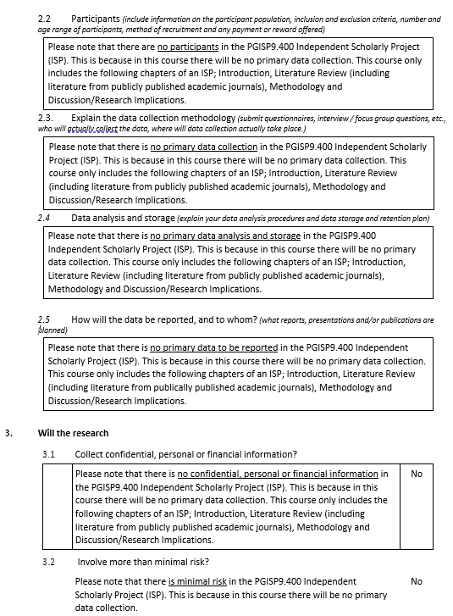

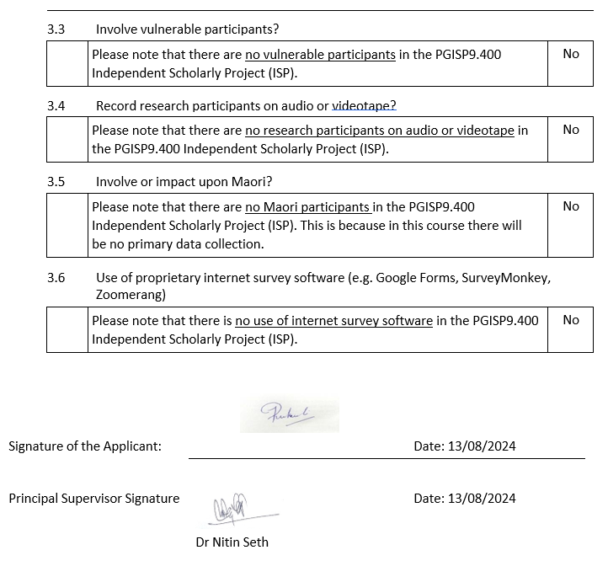

## 6.2. Approval letter

## 6.3. supervisor submission agreement



**SUPERVISOR SUBMISSION AGREEMENT- INDEPENDENT SCHOLARLY PROJECT**

Submission details

**Student Name:** Balapuwaduge Rukmali Niroshini Mendis **Student ID No:** 2023003062

Principal Supervisor: Dr Nitin Seth

*Associate Supervisor:*  NONE

ISP title: The impact of Social Media Marketing on consumer purchase intention

Submission agreement

The purpose of this form is to ensure that submitted Independent Scholarly Projects (ISP) are sufficiently well prepared to undergo timely examination. Supervisors are asked to confirm the statements below prior to the ISP being sent for examination. In the event that a supervisor is not willing to certify that an ISP is sufficiently well prepared, written comments detailing the supervisor’s concern should be attached to this form. Students are required to countersign the form to indicate awareness of the supervisor’s comments. Please note, a student can request examination of an ISP even if the supervisor has not signed off for examination. In this circumstance the examiner will be advised the ISP has not been signed off and is being examined at the student’s request.

|  |  |  |
| --- | --- | --- |
|  | **Principal Supervisor** | ***Associate Supervisor (If appointed)*** |
| In my opinion the ISP is sufficiently well prepared to be examined. | **Agreed** | **NONE** |
| The research and writing embodied in the ISP are those of the candidate except where due reference is made in the text. | **Agreed** | **NONE** |
| Assistance provided during the research phase (if undertaken) has been appropriately described and acknowledged. | **Agreed** | **NONE** |
| Editorial assistance in the writing of the ISP has been appropriately described and acknowledged. | **Agreed** | **NONE** |
| I confirm that all required ethics approval processes have been obtained for this project. | **Agreed** | **NONE** |

Sign off

**Student signature:**  ***Date*** 15/11/2024

**Principal supervisor signature:**  ***Date*** 26/11/2024

***Associate supervisor (if appointed) signature:***  ***Date*** NONE

***ISP approved for examination: Confirmed***

***Course coordinator signature: Date*** Click here to enter a date.

## 6.4. Annotated Bibliography

**Article 1**

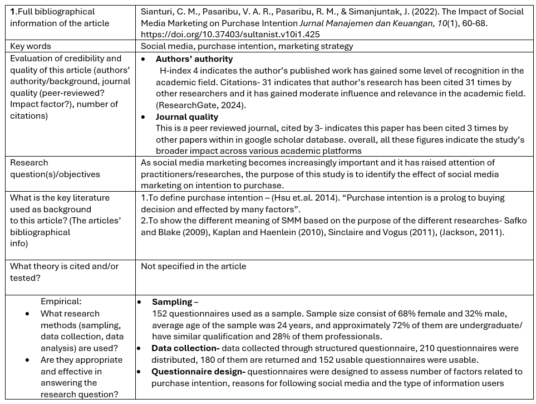

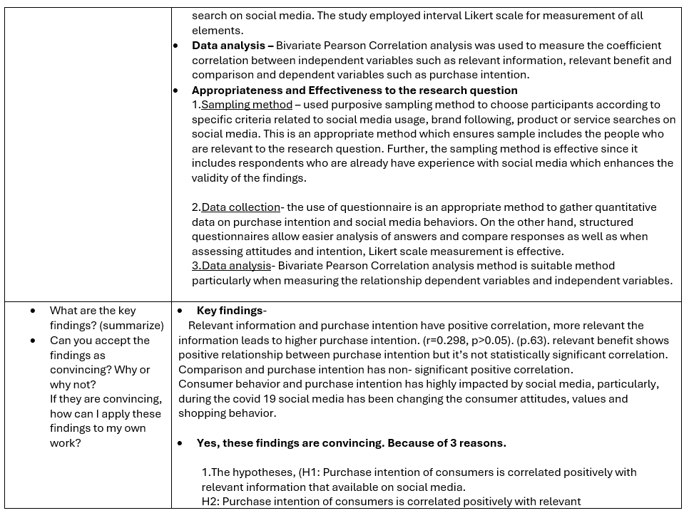

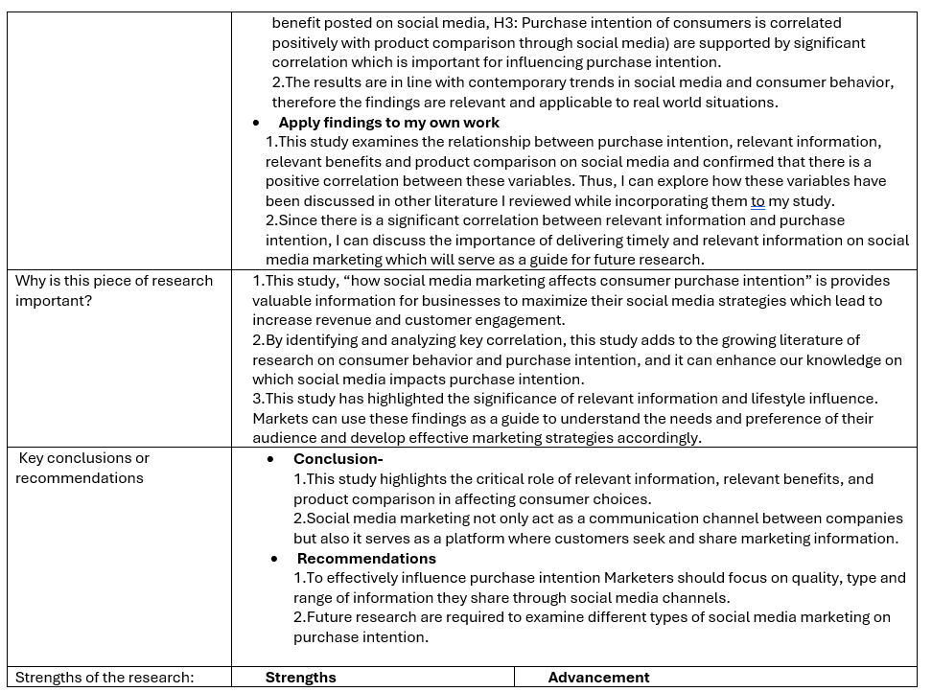

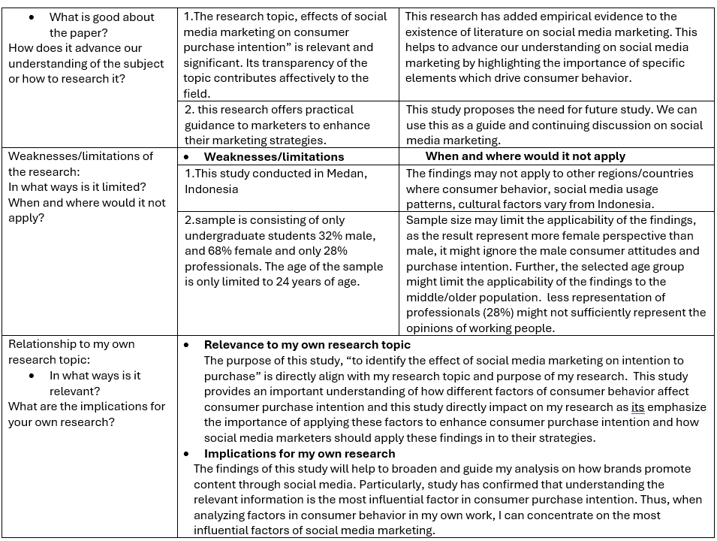

**Article 2**

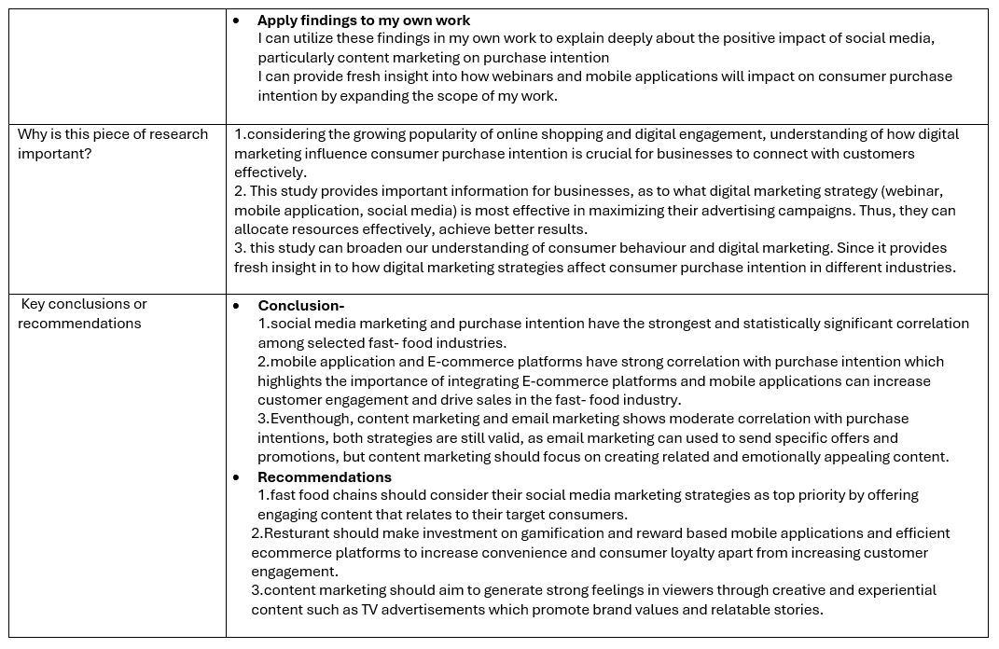

**Article 3**

**Article 4**

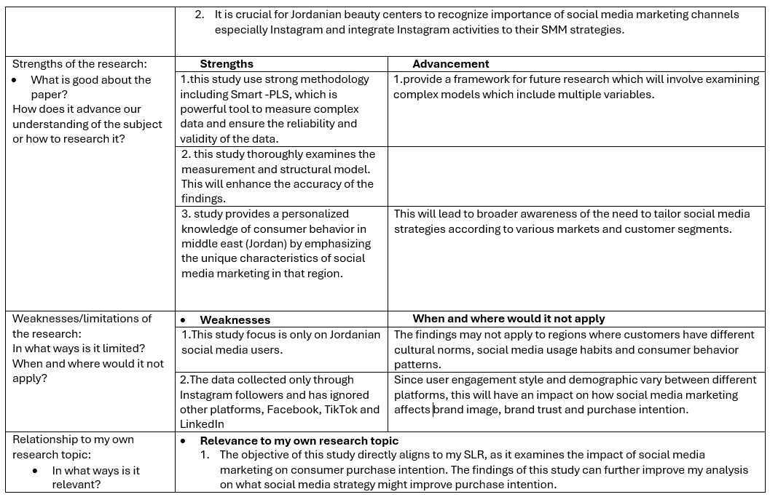**Article 5**

**Article 6**

**Article 7**

**Article 8**

**Article 10**

